Interrogative Modifier

🔹 What Is Interrogative Modifier?
# Source: AI Source: Provided by: [Data Path: Persons Table -> ID Column: 1, Name_En Column: Motasem Essam] -> From: [Chatgpt (GPT‑5 Mini)] on [8/7/2025]
An interrogative modifier is a word that modifies a noun by introducing a question. It is used in interrogative sentences and typically comes before a noun to ask which one, what kind, or how many.

🔸 Common Interrogative Modifiers:
# Source: AI Source: Provided by: [Data Path: Persons Table -> ID Column: 1, Name_En Column: Motasem Essam] -> From: [Chatgpt (GPT‑5 Mini)] on [8/7/2025]
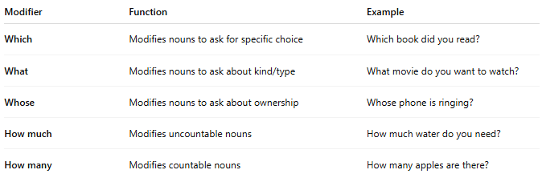
Modifier | Function | Example
Which | Modifies nouns to ask for specific choice | Which book did you read?
What | Modifies nouns to ask about kind/type | What movie do you want to watch?
Whose | Modifies nouns to ask about ownership | Whose phone is ringing?
How much | Modifies uncountable nouns | How much water do you need?
How many | Modifies countable nouns | How many apples are there?

🔸 Features:
# Source: AI Source: Provided by: [Data Path: Persons Table -> ID Column: 1, Name_En Column: Motasem Essam] -> From: [Chatgpt (GPT‑5 Mini)] on [8/7/2025]
- Always appear in questions (direct or indirect).
- Always precede the noun they modify.
- Help identify information being asked about the noun.

🔸 Examples in Sentences:
# Source: AI Source: Provided by: [Data Path: Persons Table -> ID Column: 1, Name_En Column: Motasem Essam] -> From: [Chatgpt (GPT‑5 Mini)] on [8/7/2025]
- Which route should we take?
- What color is your car?
- Whose idea was this?
- Do you know how many students passed?
- How much sugar should I add?

